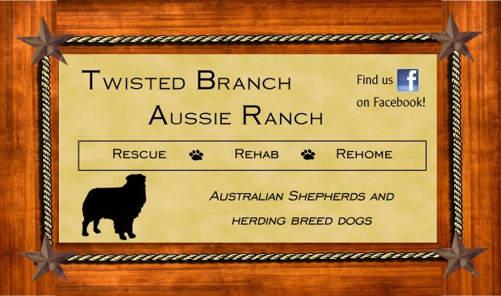
ADOPTION APPLICATION

Malakoff, Texas
twistedbranchaussies@gmail.com

Thank you for your interest in adopting a dog from Twisted Branch Aussie Ranch (TBAR). In order to adopt:
- You must be 21 years of age or older.

- You must have identification with your current address.

- You must have the knowledge and consent of all adults living in your household.

- You must be able and willing to spend the time and money necessary to provide proper care, food, training, and heartworm and preventative for your adopted dog.

At Twisted Branch Aussie Ranch, we pride ourselves in not only finding a home for our rescued dogs, but finding the perfect home for them. Finding a perfect match is important to us, the animal, and to the future pet owner. Owning a pet is a significant long-term responsibility. Following is a list of questions which will better aid us in finding a pet that is best suited for you. Please answer all of the questions thoroughly and honestly. Please remember, the animals in our care belong to TBAR, and they are adopted out at our discretion. Twisted Branch Aussie Ranch reserves the right to refuse adoption to any applicant.

Date: |  |  |  |  |  |  |  |  | Name of Dog you are interested in:
APPLICANT INFO |  |  |  |  | Name:
Address:
City: |  |  |  |  |  |  | State: |  |  |  |  |  | Zip:
Home Phone: |  |  |  |  |  |  | Cell Phone: |  |  |  |  |  | Work Phone:
DOB: |  |  |  |  |  | Drivers License No.: |  |  |  |  |  | Email:
Occupation:
SPOUSE/PARTNER INFO |  |  |  |  |  | Name:
Address:
City: |  |  |  |  |  |  | State: |  |  |  |  |  | Zip:
Home Phone: |  |  |  |  |  |  | Cell Phone: |  |  |  |  |  | Work Phone:
DOB: |  |  |  |  |  | Drivers License No.: |  |  |  |  |  | Email:
Occupation:

Please answer the following questions:
- What type of dog are you looking for?
Breed: |  | Color: |  | Age: |  | Adult Size:
- How many pets do you currently have at home?
Dog #1 Name, Breed: |  | Sex: |  | Age: |  | Spayed or Neutered? |  | On Heartworm Preventative?
Dog #2 Name, Breed: |  | Sex: |  | Age: |  | Spayed or Neutered? |  | On Heartworm Preventative?
Dog #3 Name, Breed: |  | Sex: |  | Age: |  | Spayed or Neutered? |  | On Heartworm Preventative?
Cat #1 Name, Breed: |  | Sex: |  | Age: |  | Spayed or Neutered? |  | On Heartworm Preventative?
Cat #2 Name, Breed: |  | Sex: |  | Age: |  | Spayed or Neutered? |  | On Heartworm Preventative?

- How many pets other than your current pets have you had within the past five years?
Dog #1 Name, Breed: |  | How long did you have it? |  | What happened to it?
Dog #2 Name, Breed: |  | How long did you have it? |  | What happened to it?
Dog #3 Name, Breed: |  | How long did you have it? |  | What happened to it?
Cat #1 Name, Breed: |  | How long did you have it? |  | What happened to it?
Cat #2 Name, Breed: |  | How long did you have it? |  | What happened to it?

- Where do/will your pets stay? (Indoors or Outdoors)
Current Dogs, Day: |  | Current Dogs, Night:
Current Cats, Day: |  | Current Cats, Night:
Adopted Dog, Day: |  | Adopted Dog, Night:

- Other:
Are you prepared to provide regular veterinary care for the next 10 to 20 years which would include yearly vaccinations, flea/tick treatment, and heartworm preventative? Yes/No
Our adoption approval process includes a home visit to ensure that you are able to provide a safe environment for your adopted dog. Would you be willing to allow a representative from TBAR to visit your home by appointment? Yes/No

- Please explain your living situation:
Apartment? Yes/No |  |  |  |  | House? Yes/No |  |  |  |  |  |  |  |  |  | Mobile Home? Yes/No
Do you rent? Yes/No |  |  |  |  | If you rent, you must provide written proof of pet deposit/landlord permission to have a dog in order for your application to be approved.
Do you have a fenced yard? Yes/No |  |  |  |  |  |  |  |  | What type of fence?
How tall is the fence? |  |  |  |  |  |  |  |  |  |  | Are there locks on the gates? Yes/No
If you do not have a fenced yard, explain how will you confine and exercise the dog.
Do you have a swimming pool? Yes/No |  |  |  |  |  |  |  |  |  |  | Is there a fence around the pool? Yes/No
Is there a limit to the size or number of pets you can have? Yes/No |  |  |  |  |  |  |  |  |  |  | If Yes, please explain.
How long have you lived at your current address? |  |  |  |  |  |  |  |  |  |  |  |  | Do you have plans to move soon? Yes/No
If you move, where will your adopted dog go?
On the average day, how many hours will your adopted dog be left alone?
Do you travel frequently? Yes/No |  |  |  |  |  | Who watches your pet when you travel?
Are there children in your household? Yes/No |  |  |  |  |  |  |  |  |  | What are their ages?
Are there children who visit regularly? Yes/No |  |  |  |  |  |  |  |  |  | What are their ages?
Is a new baby expected? Yes/No |  |  |  |  |  |  | If so, how will this affect your adopted dog?

- Training your adopted dog:
Would you be willing to housetrain the adopted dog if necessary? Yes/No
Have you ever housetrained a dog before? Yes/No |  |  | If yes, please explain your training methods below.
Do you have time days/evenings to devote to your dog’s exercise and training? Yes/No
Are you willing to read training books or take training classes to eliminate unwanted behavior? Yes/No
What if the personality or size of the adopted dog is not what you expected?
How would you handle problem behavior like digging, jumping up, nipping, or fence jumping/climbing?

- Medical information:
Have any of your current pets had medical problems in the last 6 months? Yes/No
If Yes, please explain.
Do you or anyone in your household have any allergies to animals? Yes/No
If Yes, please explain.
Do you currently have a veterinarian that you use? Yes/No
If you do not currently have a veterinarian, you must choose one and list their information in order for your application to be considered. We need to know that, should your newly adopted pet have an emergency, you will know where to have them treated.
Vet Clinic: |  |  |  | Veterinarian:
Address: |  |  |  | Phone:
Name of pets treated at this facility:
How long have you been a client of this vet/clinic?

- Please give a personal reference, other than a family member:
Name:
Address:
City, State, Zip: |  | Phone:

- Are there any other comments you would like to make to support your application or any questions you may have?
Comments

We do our best to place the right dog in the right home. Therefore, if we feel that the dog(s) and the applicant are not the very best match possible, we retain the right to deny this application for that particular dog. We truly appreciate your interest in helping Twisted Branch Aussie Ranch save lives by adopting, because when you adopt a dog from us you are helping to saving a life by making room for us to rescue another dog in its place.

Applicant Signature:
TBAR Representative:
Signature not required on applications submitted electronically.

